How to Work with Me
An operating manual for working with:
_____________________________

What qualities do you particularly value in people who work with you?

How can people earn an extra gold star with you?

What drives you nuts?

What’s the best way to gain your buy-in?

What’s the best way to communicate with you?

What does your ideal productive work environment look like?

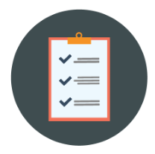

What are some honest, unfiltered things that team members would benefit from knowing about you?

